

**COMPUTATIONAL ENGINEERING MECHANICS**

**SUBJECT CODE- 19PHY104**

**PROJECT REPORT**

*Submitted b*y-

ROLL NUMBER NAME

*AM.EN.U4AIE21056 S HARI SANKAR*

*AM.EN.U4AIE21036 K SUBHASH*

*AM.EN.U4AIE21057 SAI MANASA SOUMYA*

*AM.EN.U4AIE21051 CHARISHMA AKSHAYA*

*AM.EN.U4AIE21052 R RAKESH*

**INDEX**

1. PROBLEM 1
2. PROBLEM 2
3. PROBLEM 3
4. PROBLEM 4
5. PROBLEM
6. PROBLEM 6
7. PROBLEM 7

1. **PROBLEM 1**

***PROBLEM DEFENITION***

The given figure is a real-life example of bridge trusses. There's a vehicle with load 81 kN. Due to the weight of the car the load at points L and K of the bridge truss is of magnitude 40.5 kN. With the help of method of joints and sections analyze the forces in AN, AB ,NM,MC, NB , BM, BC, CL, DE, DK by finding out the forces on each truss members. Using MATLAB

1. Get the load of the vehicle and draw the graph of force variation with the load from 1kN to the given value
2. Get the angle of the bridge and load from user and draw the graph between angle and force variation. Assuming the while the angle changes the base length remains the same whereas the height is changed.
3. Get the maximum truss force supported from the user and give the max load supported in the truss

***METHODOLOGY***

|  |
| --- |
| **CONCEPTS USED IN THE QUESTION** |
| **1.VECTORS AND COMPONENTS OF VECTORS** |
| **2.SUPPORTS AND SUPPORT REACTION** |
| **3.FORCE EQUILIBRIUM** |
| **4.METHOD OF JOINTS** |
| **5.METHOD OF SECTIONS** |

*Step 1 – Find the support reactions of the truss by taking the system as a whole and applying equilibrium*

*Step 2 – Analysing each joint by method of joints and by using the concept of equilibrium*

*Step 3 – Finally using method of sections to find the remaining truss forces by using the concept of equilibrium*

*Step 4 – Applying matlab code for various truss members by making load and angle as a variable*

***CALCULATIONS***







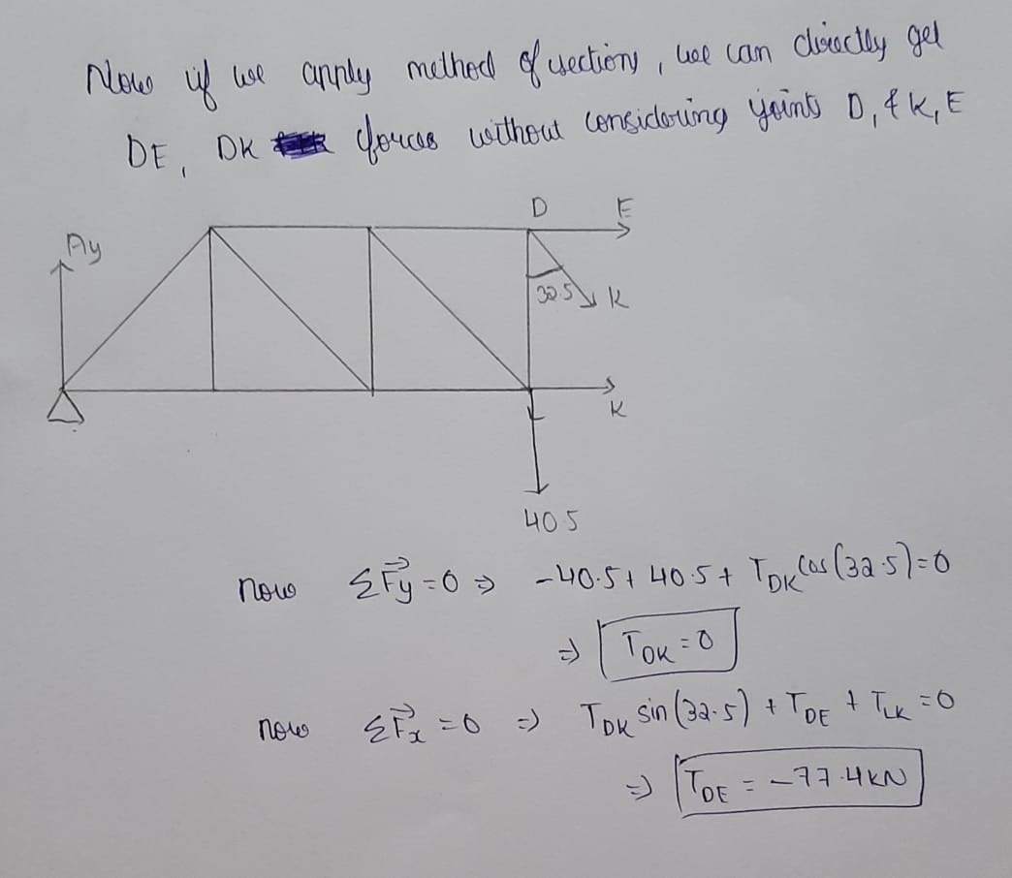

***MATLAB***

%Code for bridge truss 1

% asking the user what to do using switch

disp("Enter what would you like to do ")

disp("1.variation of truss forces with load")

disp("2.variation of truss forces with load and angle ")

disp("3.find out the max load by giving the max truss force bearable ")

n=input("Enter the choice ");

switch n

case 1

P=input("Enter the load of the vechile ");

p=P/2;

x=floor(p);

% creating matrices for storing values calculated in every iteration

AN=0:x;

BM=0:x;

MC=0:x;

BC=0:x;

DE=0:x;

y=0:x;

for i=0:x

% performing computations for each member and storing in matrices

AN(1,i+1)=i*cotd(57.5);

BM(1,i+1)=i*cscd(57.5);

MC(1,i+1)=i;

BC(1,i+1)=-2*i*cotd(57.5);

DE(1,i+1)=-3*i*cotd(57.5);

End

% plotting graphs for each member

figure

plot(y,AN);

title("Variation of force in AN with load");

xlabel("load in kN");

ylabel("Truss force in kN");

figure

plot(y,BM);

title("Variation of force in BM with load");

xlabel("load in kN");

ylabel("Truss force in kN");

figure

plot(y,BC);

title("Variation of force in BC with load");

xlabel("load in kN");

ylabel("Truss force in kN");

figure

plot(y,DE);

title("Variation of force in DE with load");

xlabel("load in kN");

ylabel("Truss force in kN");

case 2

%Matlab code for part 2

t = input("Enter the angle BAN ");

P=input("Enter the load of the vechile ");

p=P/2;

AN=1:t;

BM=1:t;

BC=1:t;

DE=1:t;

y=1:t;

for i=1:t

AN(1,i)=p*cotd(i);

BM(1,i)=p*cscd(i);

BC(1,i)=-2*p*cotd(i);

DE(1,i)=-3*p*cotd(i);

end

figure

plot(y,BM);

title("Variation of force in BM with angle ");

xlabel("angle in degrees ");

ylabel("Truss force in kN");

figure

plot(y,BC);

title("Variation of force in BC with angle ");

xlabel("angle in degrees ");

ylabel("Truss force in kN");

figure

plot(y,DE);

title("Variation of force in DE with angle ");

xlabel("angle in degrees ");

ylabel("Truss force in kN");

case 3

% asking the user the maximum force each truss can bear

m=input("Enter the max truss force each of the truss can bear ");

% asking the user the maximum force each truss can bear

% in generalized equations we find that for a given load the max truss force is

%3pcot(57.5) and it is going to break first

p=m/(3*cotd(57.5));

disp("The maximum load the bridge can bear in kN is ")

disp(2*p)

end

***RESULT***













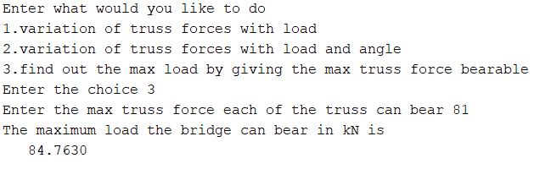

***INTERPRETATION***

By using matlab-

* we are plotting the variation of forces with the variation of load acting and the plots that we are getting are all straight line curves
* we are also plotting the variation of forces in trusses with respect to the angle of bridge truss which. The plots we obtained are not straight lines but curves.
* The above plots can be used to identify the forces in the given members for a particular load or for a particular load and angle

1. **PROBLEM 2**

***PROBLEM DEFENITION***

A rod with two supports are given in the question. The rod induces a function of y=x^2 as shown in the figure. The support at A is a roller support whereas at B is a hinge support. Given weight per unit length is 100. Based on the data given in the figure-

A)Determine the vertical reaction at A and B

B)locate the center of gravity

C)Using MATLAB make the x coordinate of B point as a user input find out the location of center of gravity

D)Using MATLAB plot the graph of variation of location of center of gravity with x coordinate of b

E)Using MATLAB get the weight per unit length from the user and calculate the support reactions

F)Using MATLAB plot the variation of support reactions with weight per unit length

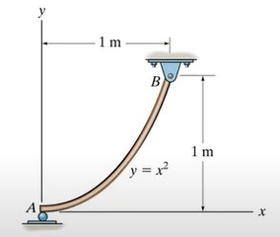

***METHODOLOGY***

|  |
| --- |
| **CONCEPTS USED IN THE QUESTION** |
| 1.CENTROID |
| 3CENTRE OF GRAVITY |
| 3.FORCE EQUILIBRIUM |
| 4.SUPPORTS AND SUPPORT REACTIONS |

*Step 1 – Taking a small elemental length dl and finding the relationship between dx,dy and dl*

*Step 2 – Applying it in formulae for finding out the value of Xcom and Ycom with the help of integration*

*Step 3 –Identifying the support reactions and drawing the free body diagram.*

*Step 4 – Finding out the support reactions with the help of the concept of equilibrium*

*Step 5 – Applying the formulae in MATLAB and getting the out put*

***CALCULATIONS***

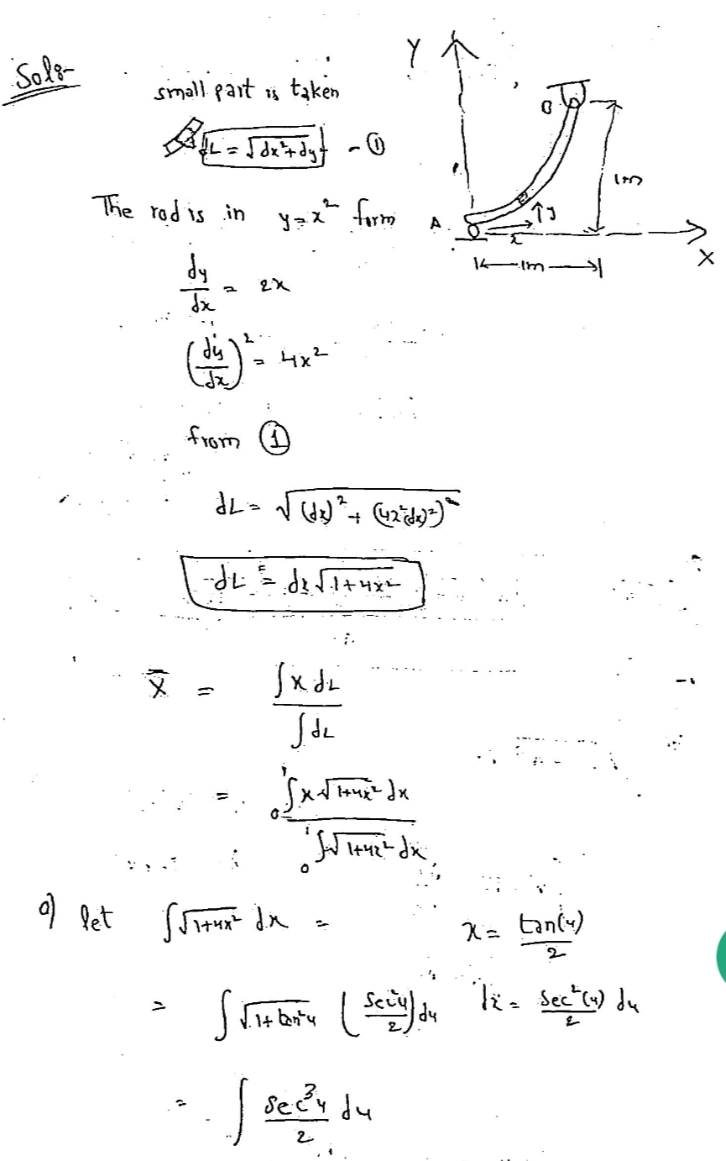

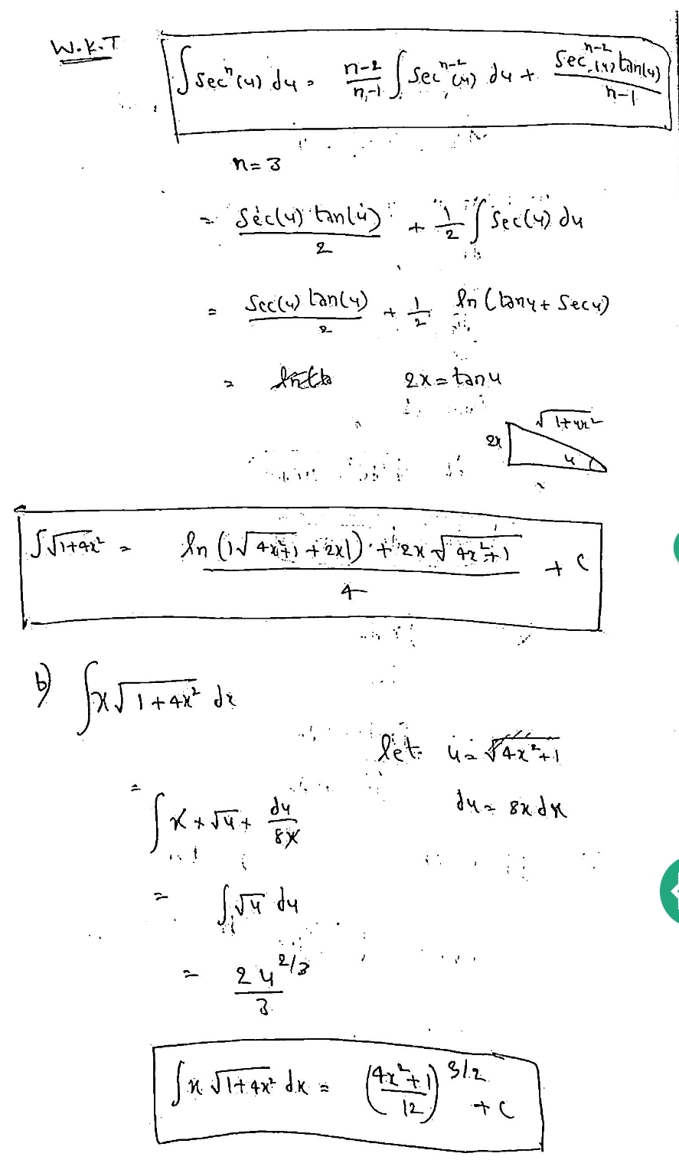

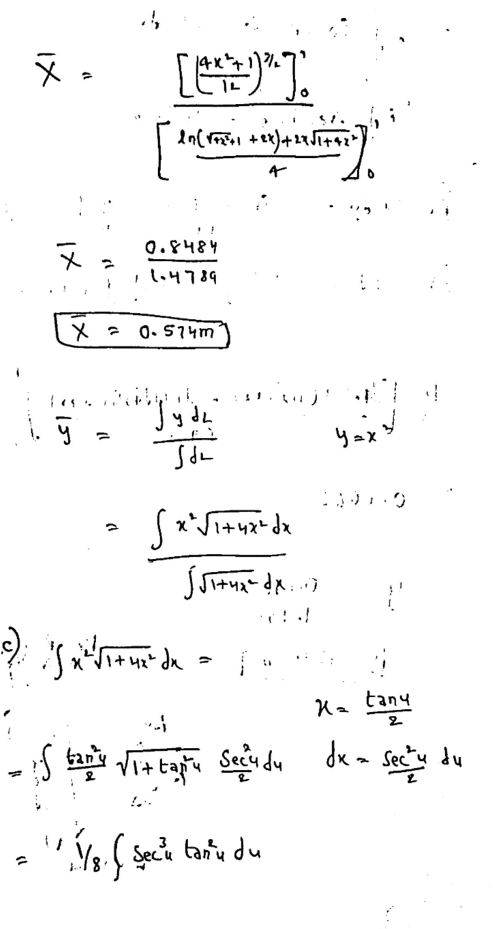

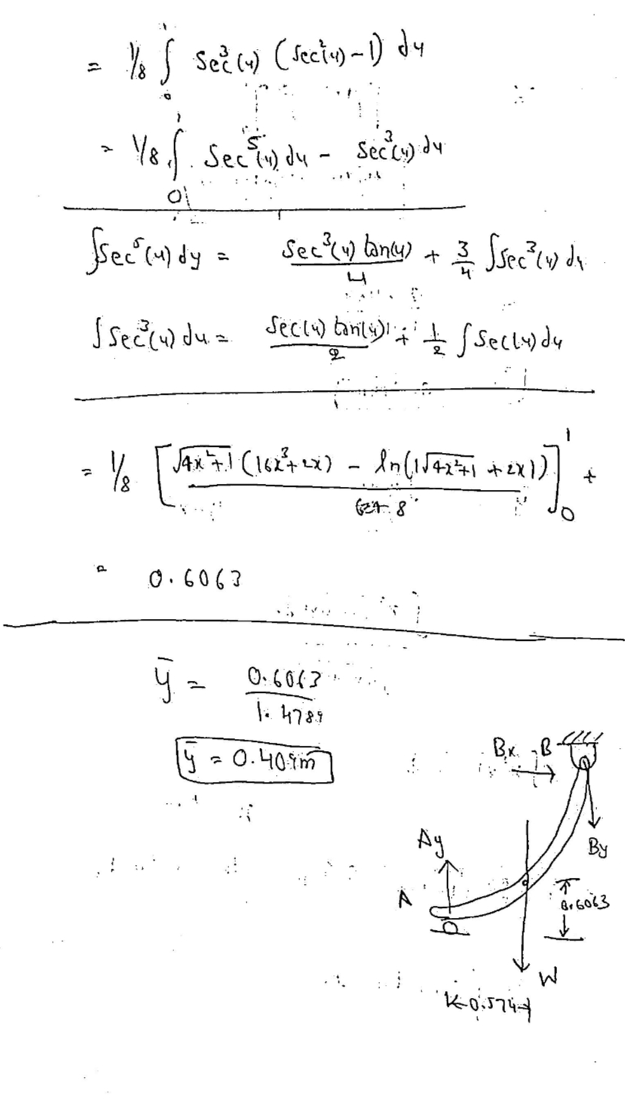

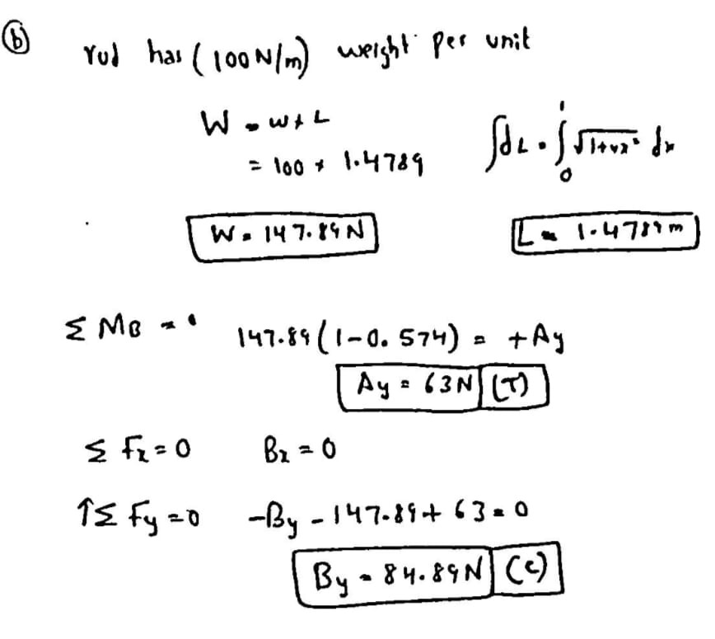

***MATLAB***

%MATLAB PART FOR THE 1ST QUESTION

%Getting the x coordinate of B

in = 'input the value of x coordinate of B ';

x = input(in);

%applying the value of x in the integrated formulaes obtained

X1 = ((((4*(x^2))+1)^1.5)/12)-0.0833;

X2 = (log((4*(x^2) +1)^0.5+(2*x))+(2*x*((4*(x^2) +1)^0.5)))/4;

Xcm=X1/X2;

Y1=(((4*(x^2) +1)^0.5).*(16*(x^3) + 2*x)-log((4*(x^2) +1)^0.5 +2*x))/64;

Y2 = (log((4*(x^2) +1)^0.5+2*x)+(2*x*((4*(x^2) +1)^0.5)))/4;

Ycm= Y1/Y2;

disp("The value of Xcom is ")

disp(Xcm)

disp("The value of Ycom is ")

disp(Ycm)

%creating array for storing values

e=1:x;

xc=1:x;

yc=1:x;

for i=1:x

X1 = ((((4*(i^2))+1)^1.5)/12)-0.0833;

X2 = (log((4*(i^2) +1)^0.5+(2*i))+(2*i*((4*(i^2) +1)^0.5)))/4;

xc(1,i)=X1/X2;

Y1=(((4*(i^2) +1)^0.5).*(16*(i^3) + 2*i)-log((4*(i^2) +1)^0.5 +2*i))/64;

Y2 = (log((4*(i^2) +1)^0.5+2*i)+(2*x*((4*(i^2) +1)^0.5)))/4;

yc(1,i)=Y1/Y2;

end

%ploting variation of different values

figure;

plot(e,xc)

title("The variation of XCOM with x cordinate of b")

xlabel("X coordinate of B ")

ylabel("XCOM coordinate ")

figure;

plot(e,yc)

title("The variation of YCOM with x cordinate of b")

xlabel("X coordinate of B ")

ylabel("YCOM coordinate ")

%MATLAB CODE FOR 2ND PART

in = 'input the value of x coordinate of B ';

x = input(in);

X1 = ((((4*(x^2))+1)^1.5)/12)-0.0833;

X2 = (log((4*(x^2) +1)^0.5+(2*x))+(2*x*((4*(x^2) +1)^0.5)))/4;

Xcm=X1/X2;

Y1=(((4*(x^2) +1)^0.5).*(16*(x^3) + 2*x)-log((4*(x^2) +1)^0.5 +2*x))/64;

Y2 = (log((4*(x^2) +1)^0.5+2*x)+(2*x*((4*(x^2) +1)^0.5)))/4;

Ycm= Y1/Y2;

L=(log((4*(x^2) +1)^0.5+(2*x))+(2*x*((4*(x^2) +1)^0.5)))/4;

%Getting the weight per unit length from the user

W=input("Enter the weight per unit length ");

%formulating the ay and by values

%also creating arrays for storing values

ay=1:W;

by=1:W;

w=1:W;

t=L*W;

AY=t*(x-Xcm);

BY=AY-t;

disp("AY is ")

disp(AY)

disp("BY is ")

disp(BY)

for i=1:W

t=L*i;

ay(1,i)=t*(x-Xcm);

by(1,i)=(ay(1,i))-t;

end

%plotting variations

figure;

plot(w,ay)

title("The variation of AY with Weight per unit length")

xlabel("Weight per unit length ")

ylabel("AY in N ")

figure;

plot(w,by)

title("The variation of BY with Weight per unit length")

xlabel("Weight per unit length ")

ylabel("BY in N ")

***RESULT***









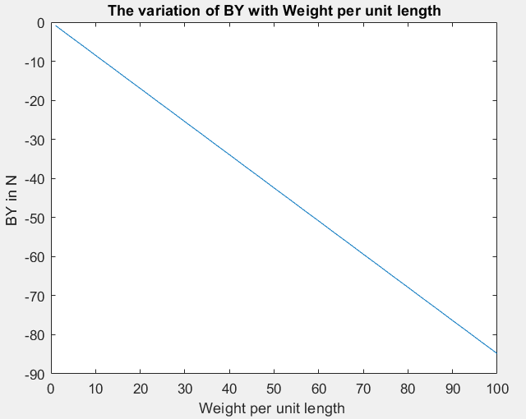

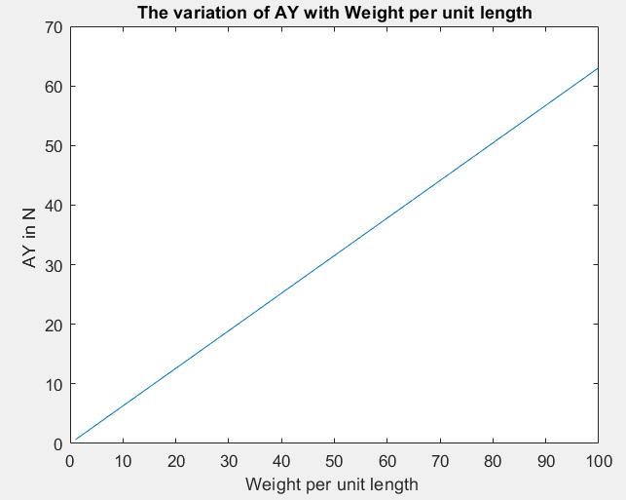

***INTERPRETATION***

BY USING MATLAB –

* We are getting the coordinates of centre of mass with a given value of x coordinate from the user.
* We are drawing the variation of the position of YCom and Xcom with respect to the x coordinate of the point B.The plot that we get is a straight line plot
* We are also drawing the variation of support reactions and weight per unit length of the rod. The plot obtained is a straight line plot.

**III.PROBLEM 3**

There is a curved road of radius 24m banked with an inclination theta 21 degrees present in a road. A car of mass 50 kg rides through

a. Find the frictional force acting on the car if the velocity with which the car moves is 8m/s. Also derive the formulae for max velocity and angle of banking for a given mass M of the car?

b. Using MATLAB plot the variation of frictional force and mass from 1 to M kg?

c. Using MATLAB take the input from user for different parameters and find the max velocity of the car?

d. Using MATLAB plot the variation of Banking Angle theta and the max velocity after taking the input from the user?

***METHODOLOGY***

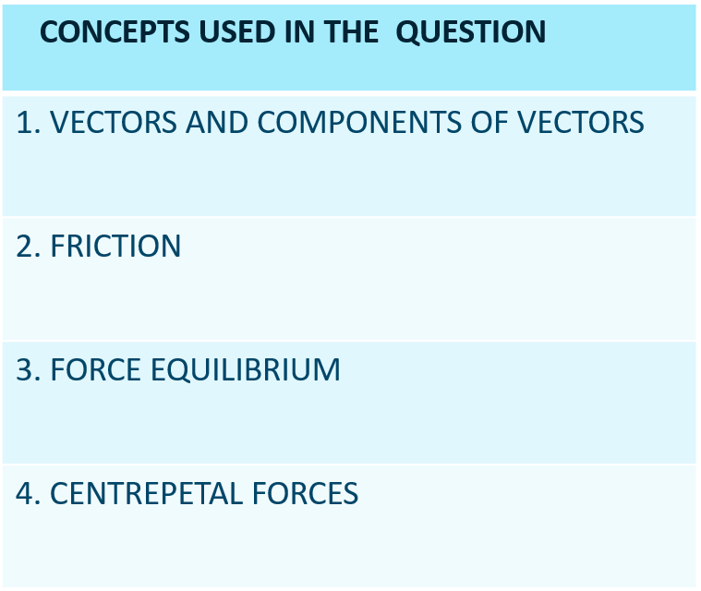

*Step 1 – Drawing the free body diagram by considering various forces acting on the object*

*Step 2 – Applying the concept of equilibrium and finding out the friction*

*Step 3 – Formulating the value of max velocity*

*Step 4 -Applying the formulae in matlab and drawing the required plots*

***CALCULATIONS***

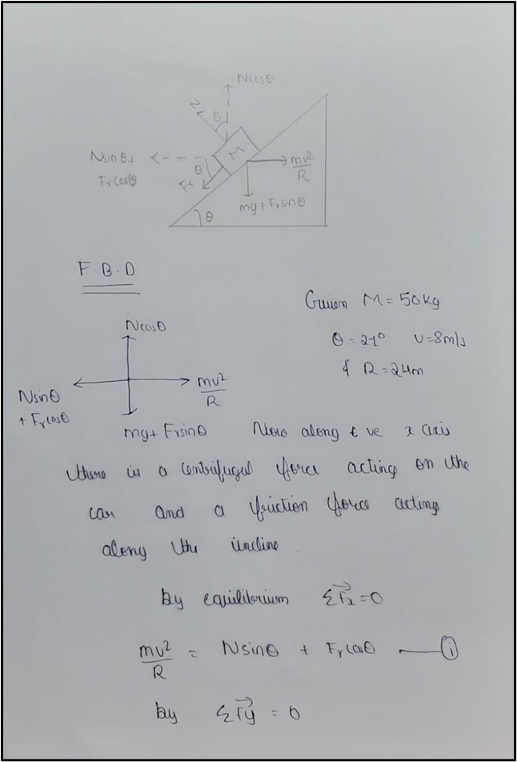

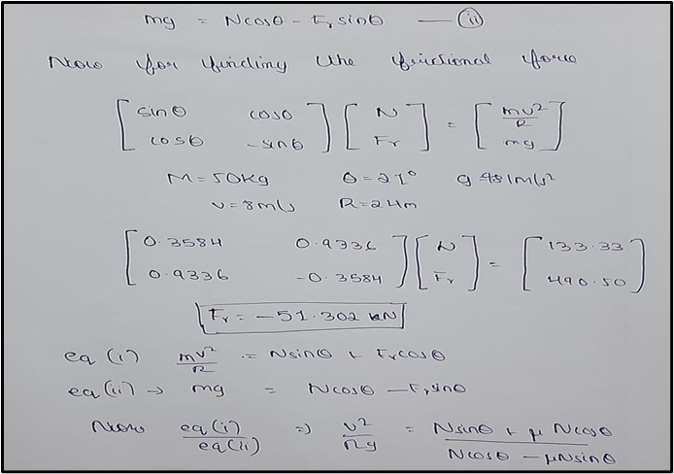

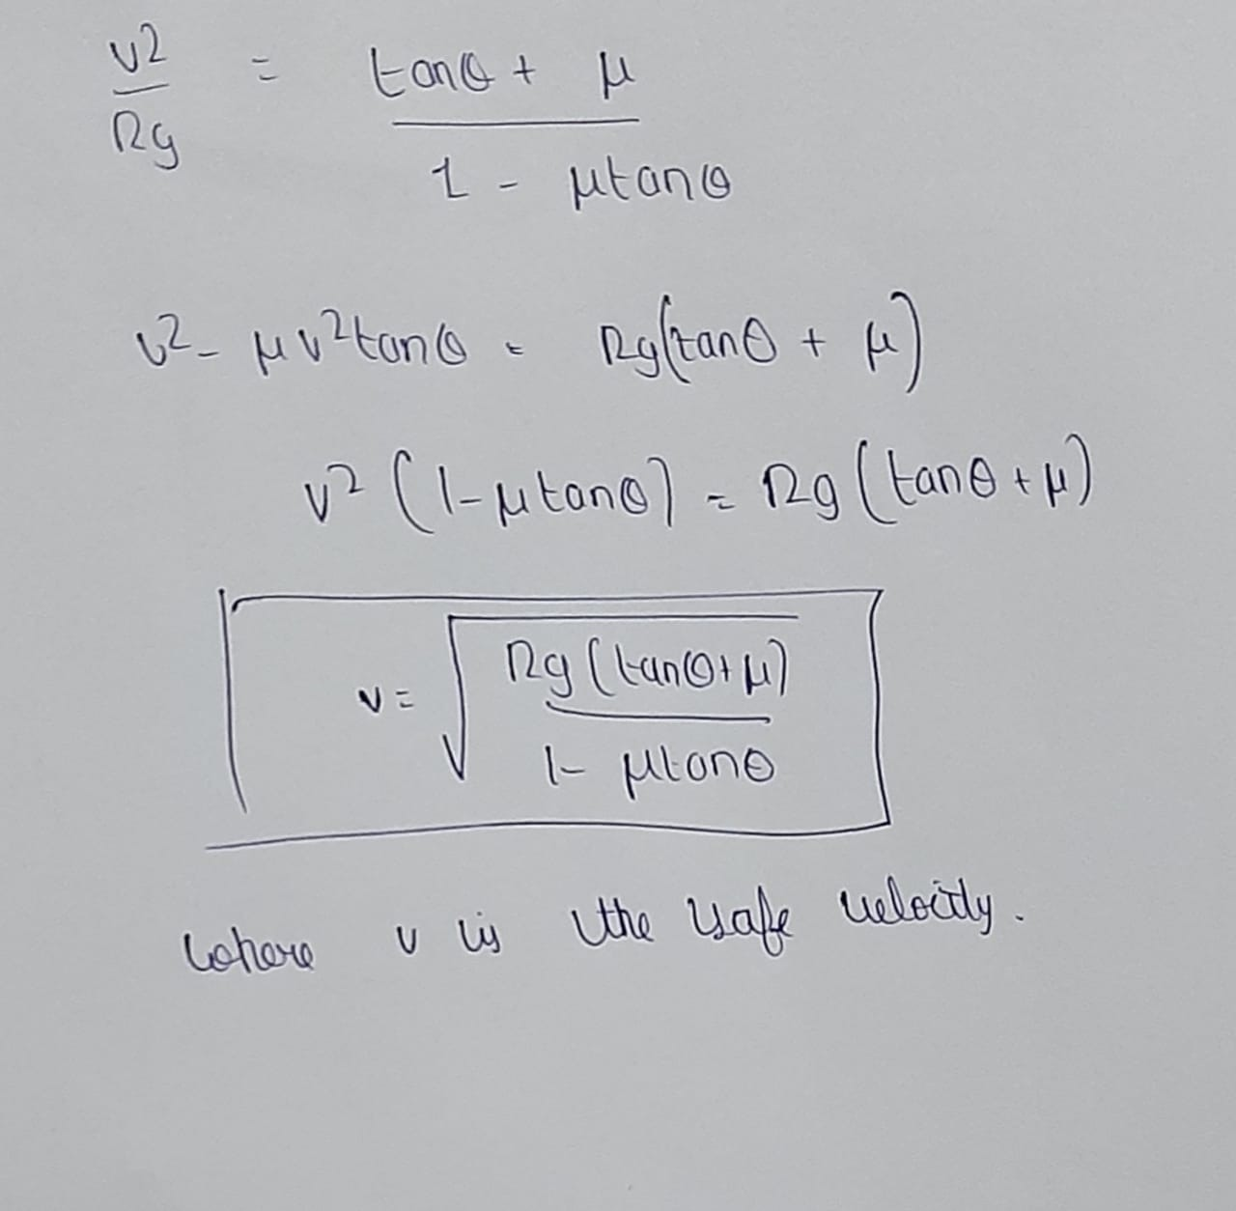

***MATLAB***

%Friction in banking of roads

disp("Enter the action required to do ")

h=input("1.FINDING FRICTIONAL FORCE 2.FINDING VMAX 3.FINDING ANGLE OF BANKING")

switch h

case 1

m=input("Enter the mass of the car ");

t=input("Enter the the inclination angle in degrees ");

v=input("Enter the velocity of the car ");

r=input("Enter the radius of curve ");

a=[sind(t) cosd(t);cosd(t) -sind(t)];

inva=inv(a);

b=[(m*(v.^2)/r);(m*9.81)];

x=inva*b;

x1=1:m;

disp("The frictional force acting is ")

disp(x(2,1))

for m1=1:m

b=[(m1*(v.^2)/r);(m1*9.81)];

x=inva*b;

x2=x(2,1);

x1(1,m1)=x2;

end

m1=1:m;

plot(m1,x1)

title("Variation of friction with mass of the car");

xlabel("Mass in kg");

ylabel("Friction in N");

case 2

%Velocity max when theta and coefficient of friction is given

t=input("Enter the the inclination angle in degrees ");

r=input("Enter the radius of curve ");

m=input("Enter the mass of the car ");

u=input("Enter the friction coefficient of the road ");

num=r*9.81*(tand(t)+u);

deno=(1-(u*tand(t)));

fr=num/deno;

v=sqrt(fr);

disp("The max velocity with which car should be moved is ")

disp(v)

case 3

%angle of banking when max velocity and radius is given and graph

u=input("Enter the friction coefficient of the road ");

r=input("Enter the radius of curve ");

v=input("Enter the max velocity of the car ");

num=1-u;

deno=(v*v*u/(r*9.81))+1;

t=atand((num/deno));

disp("The inclination angle is ")

disp(t)

v1=1:v;

t1=1:v;

for v2=1:v

num=1-u;

deno=(v2*v2*u/(r*9.8))+1;

t1(1,v2)=atand((num/deno));

end

figure;

plot(v1,t1)

title("Variation of banking angle with max veloity of the car");

xlabel("velocity in m/s");

ylabel("theta in degrees");

end

***RESULT***











***INTERPRETATION***

* plots drawn using MATLAB can be used to view the variation of friction with mass and the plot is a straight line
* We are also drawing the variation the banking angle with respect maximum velocity which gives us a curved plot
* Furthermore the above question gives us a view of how friction is an essential component in our day to day life

**IV.PROBLEM 4**

***PROBLEM DEFENITION***

Roof trusses are examples of truss structures in our everyday life. During winter, snow loads up at the roof causing a load 3x + 5 on the points B,C AND D where x is the a specific day of winter. eg. On the 27th day of winter, x will be 27N. And there is a constant snow fall for 30 days.

a) If the max stress force which can maintained by any truss is 140N, find upto how many days in the winter will the roof truss be able to support the house and draw the graph upto the day at which the truss fails.

b) The angle theta is inputted from the user for the load of x N on points B, C and D and then to find the variation of forces in AB,AG from theta = 1 to given value. (ie. Ignore the dimensions in the figure)

***METHODOLOGY***

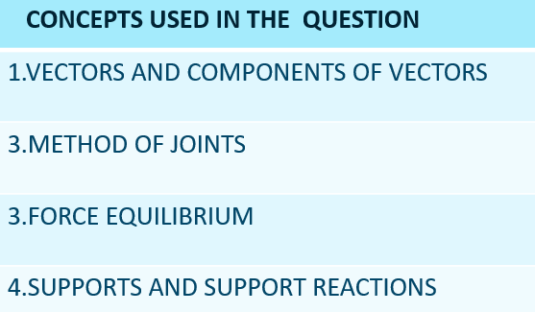

*Step 1 – Find the support reactions of the truss by taking the system as a whole and applying equilibrium*

*Step 2 – Analysing each joint by method of joints and by using the concept of equilibrium*

*Step 4 – Applying matlab code for various truss members by making load and angle as a variable*

***CALCULATIONS***

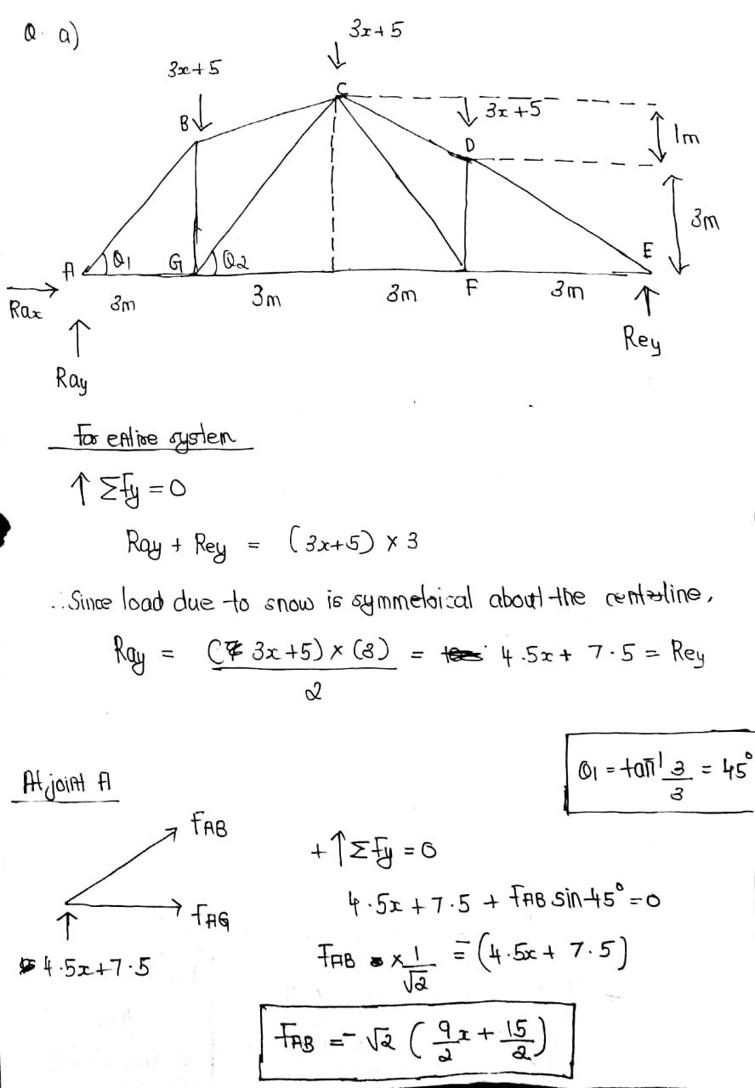

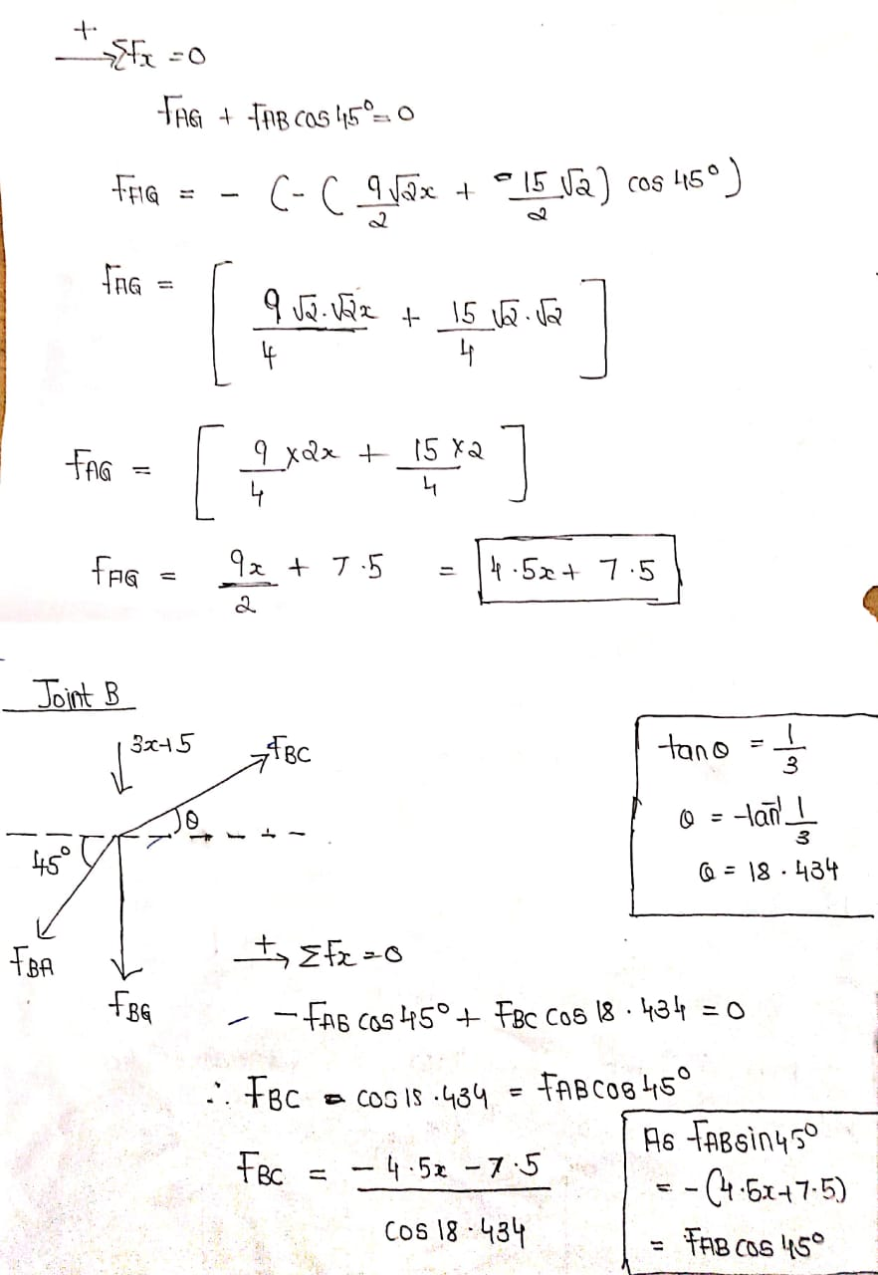

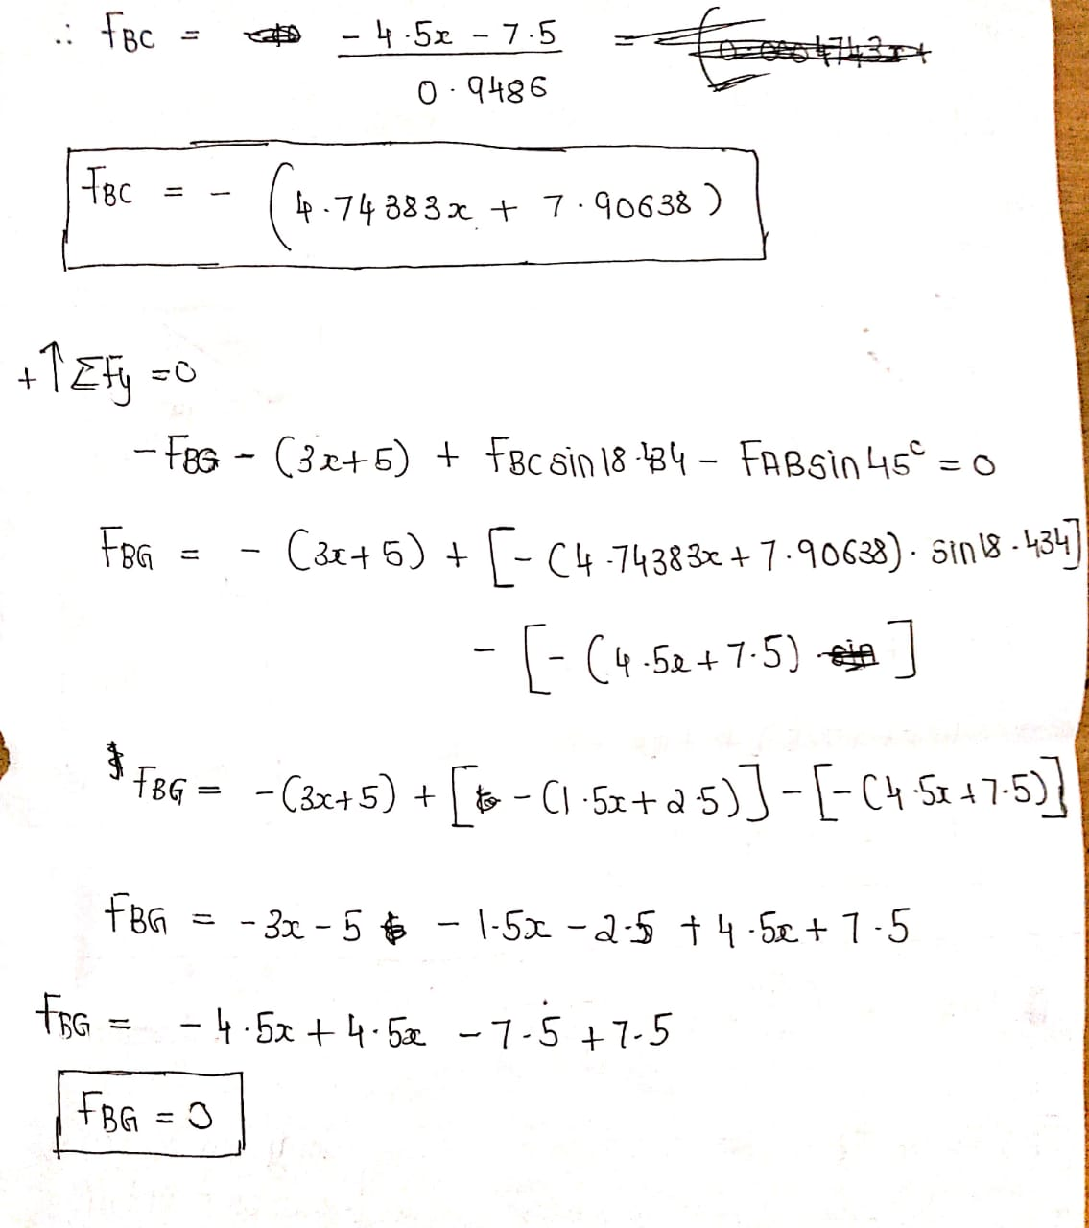

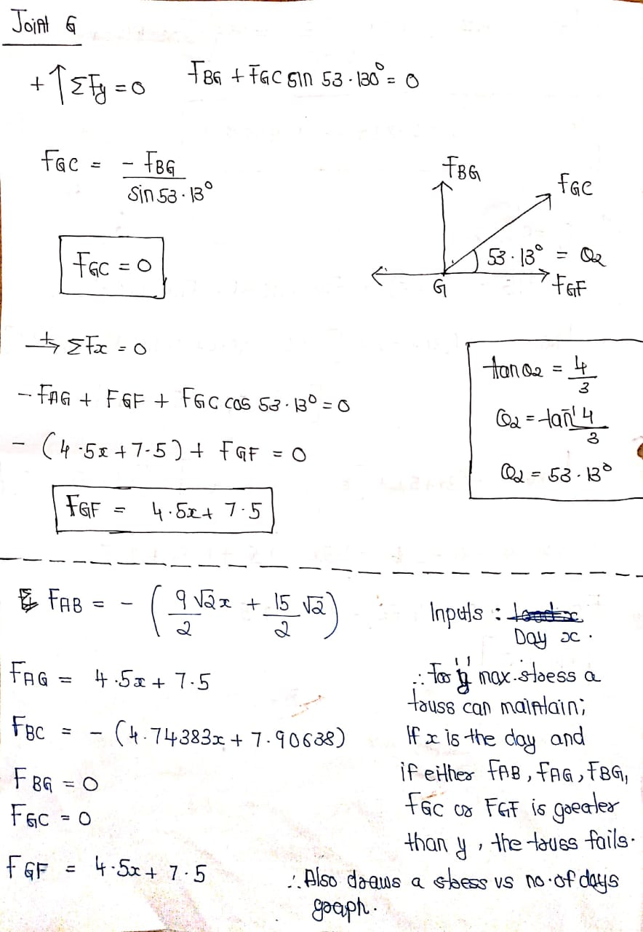

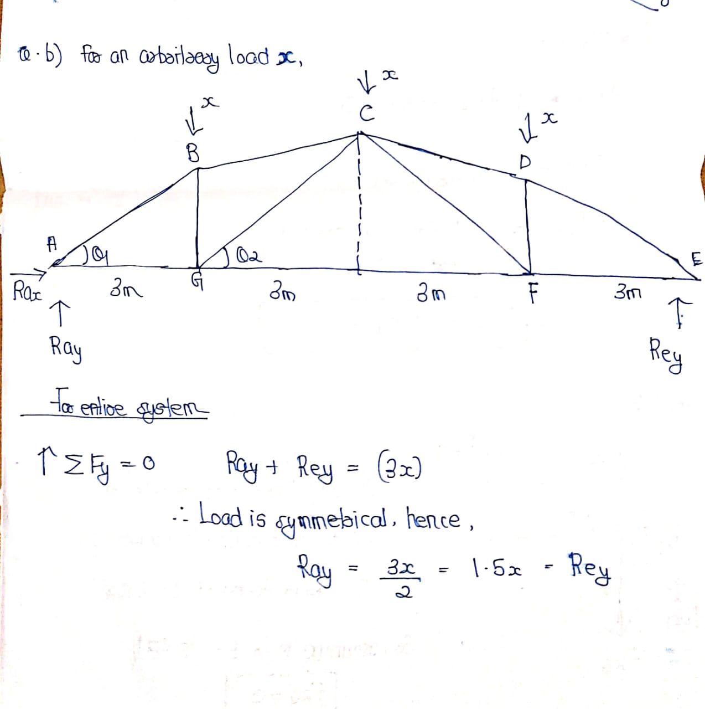

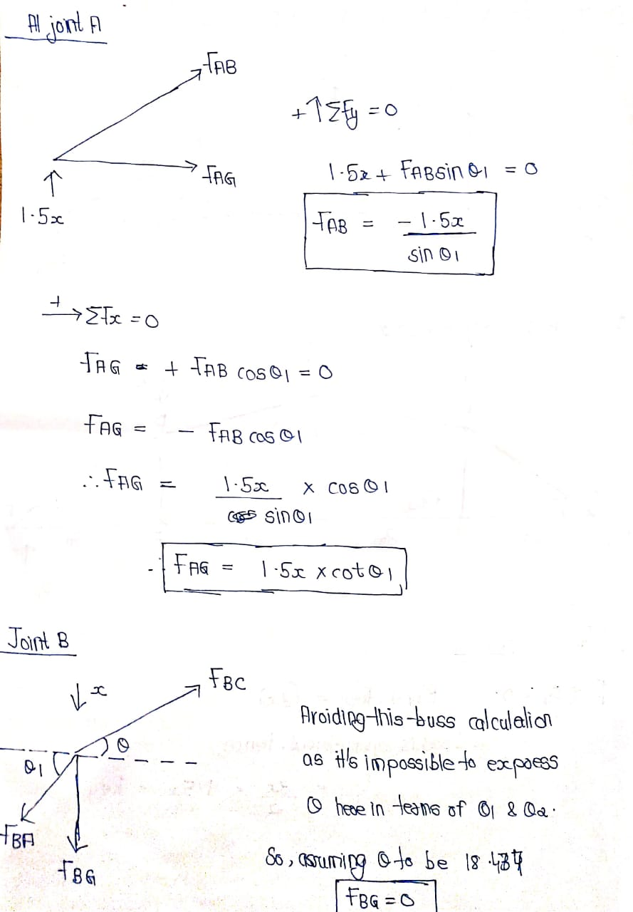

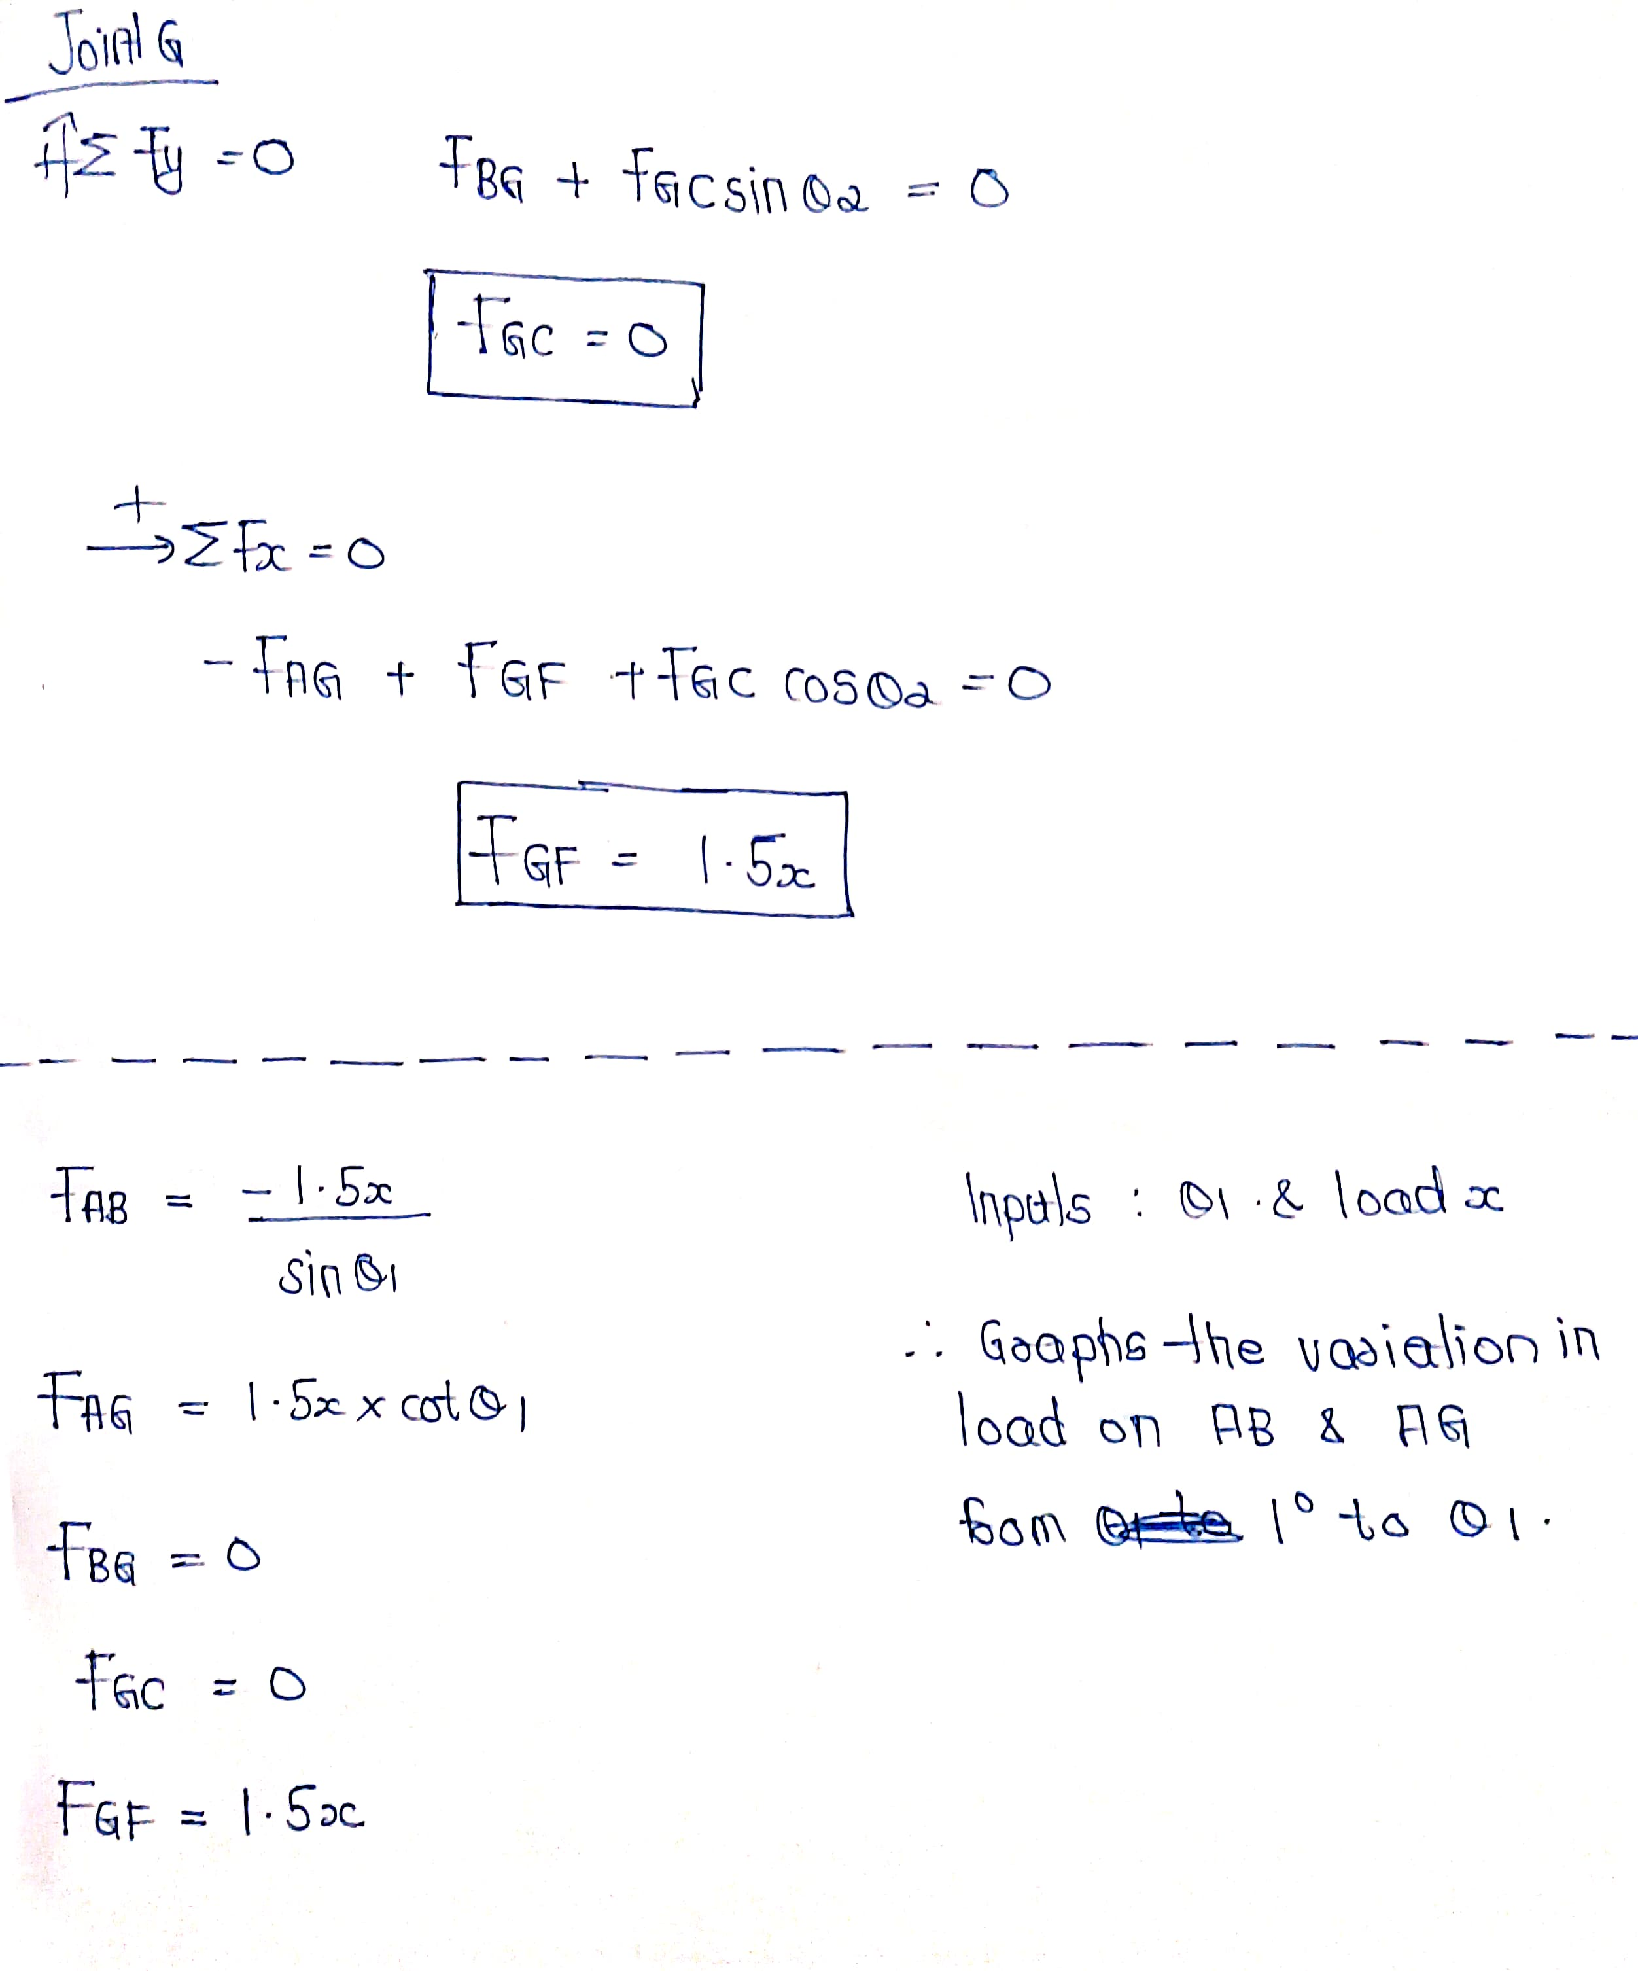

***MATLAB***

disp("Snow Fall has begun. It will continue for 30 Days. Maximum Stess maintained by any truss is 140N. Enter your choice below: ");

a = input("1. For an arbitrary day 'X' after snow fall has begun, find if the truss would fail." + newline + "2. For an arbitrary load 'x' on B,C & D, Enter the angle 'Θ'(∠CGF in the fig. ; in degress) and plots the variation of load on AB & AG from 1° to 'Θ' " + newline + "Enter your choice: ");

s = sqrt(2);

switch a

case 1

disp("Enter the day 'X' for which the stress on the trussess due to snow is calculated and graph is plotted.")

x = input("Enter X (0 to 30): ");

fab = ((9/s)*(x) + 15/s); %Compression ; Taken Negative to get the positive value. Fab will always fail first.

fag = (4.5)*(x) + 7.5;

fbc = (4.74383)*(x) + 7.90638; %Compression ; Taken Negative to get the positive value.

fbg = 0;

fgc = 0;

fgf = (4.5)*(x) + 7.5;

Main = [fab fag fbc fbg fgc fgf];

Main2 = Main > 140;

Main3 = any(Main2);

if Main3==true

disp("*****The Roof Truss has failed for the given day X.*****");

else

disp("***The Roof Truss has not failed for the given day X.***")

end

Main4 = [];

for i = 1:21

fmain = ((9/s)*(i) + 15/s);

Main4(end+1)=fmain;

end

x1=1:21;

y1=Main4;

ln = plot(x1,y1);

xlabel('Days')

ylabel('Force On Truss AB(N)')

title('Days Vs Force(C/T) On Truss AB(N)')

xticks(1:21);

yticks(Main4);

xtickangle(45)

ln.LineWidth = 2;

ln.Color = [0 0.5 0.5];

ln.Marker = 'o';

ln.MarkerEdgeColor = 'b';

case 2

x2 = input("Enter Load 'X' on B,C & D(N) : ");

theta = input("Enter 'Θ'(∠CGF in the fig. ; in degress): ");

fab2 = ((-1.5)*(x2)/(sin(theta)));

fag2 = ((1.5)*(x2)*(cot(theta)));

Main5 =[];

Main6=[];

for i = 1:theta

fab2main = -((-1.5)*(i)/(sin(theta)));

fag2main = ((1.5)*(i)*(cot(theta)));

Main5(end+1)=fab2main;

Main6(end+1)=fag2main;

end

x3 = 1:theta;

y3 = Main5;

ln1 = plot(x3,y3);

xlabel("Theta (in degrees)")

ylabel("Forces On AB and AG(N)")

title("Variation Of Forces On AB and AG w.r.t the angle 'Θ'(∠CGF in the fig.)")

xtickangle(45)

ln1.LineWidth = 2;

ln1.Color = [0 0.5 0.5];

ln1.Marker = 'o';

ln1.MarkerEdgeColor = 'b';

hold on

y4 = Main6;

ln2= plot(x3,y4);

legend('AB','AG')

ln2.LineWidth = 2;

ln2.Color = [0 0.5 0.5];

ln2.Marker = 'o';

ln2.MarkerEdgeColor = 'r';

end

***RESULT***

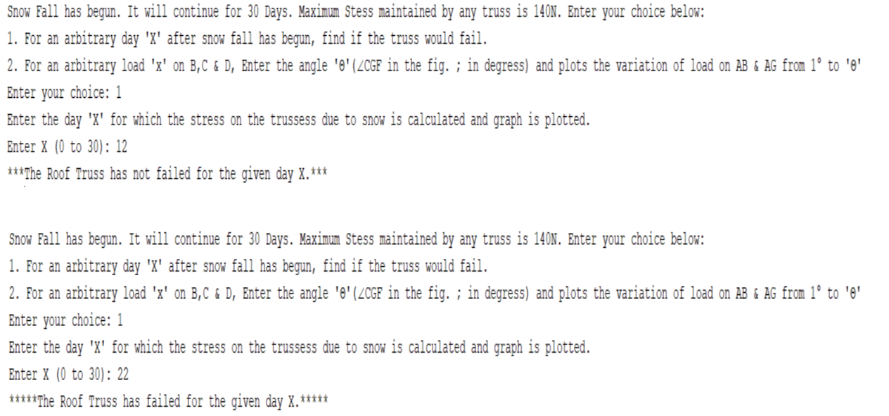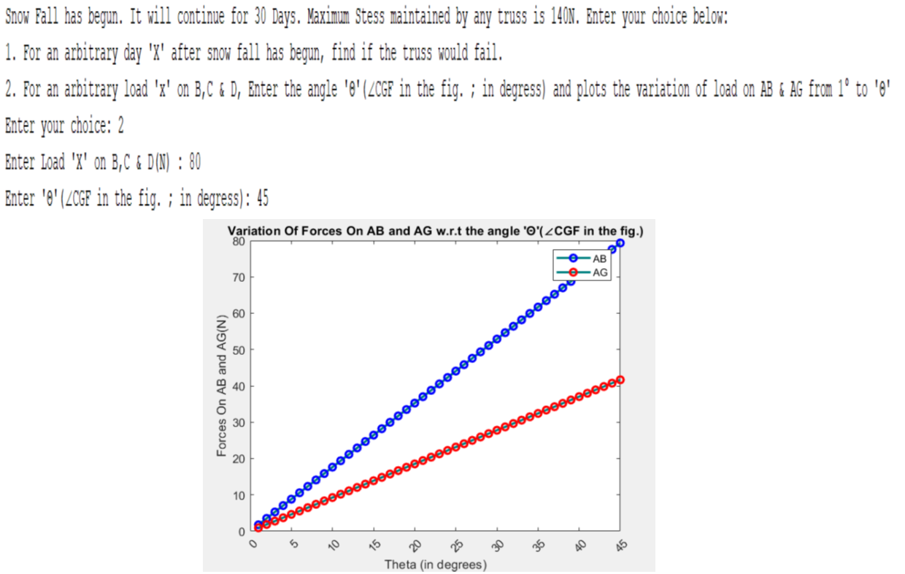

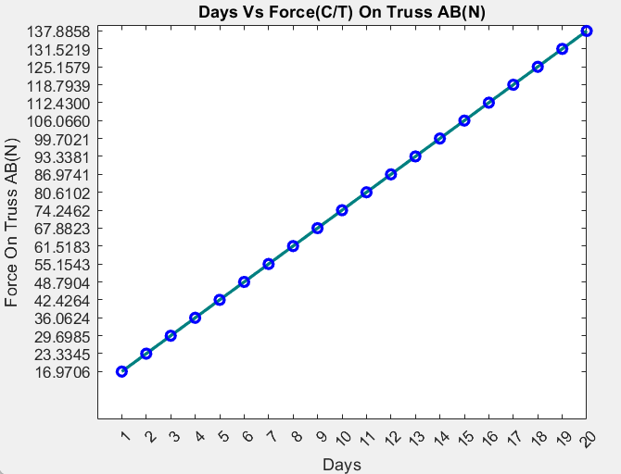

***INTERPRETATION***

With the help of MATLAB

* we are plotting the variation of forces in truss AB until it breaks and the truss fails which is a straight line
* we are also plotting the variation of forces in AB and AG as the load and the angle is varied which is a straight line
* we are also checking whether for a given day whether the truss breaks or not

**V.PROBLEM 5**

***PROBLEM DEFENITION***

A gasoline engine producing 150 Nm of torque is used to drive a winch and lift a weight. In the figure the winch drum has a radius of 0.25 m and it is driven from the engine via 1:50 speed reduction gear(speed reduction = W(winch)/.

What mass could be raised with system assuming that mass moves with a constant velocity?

Using matlab get the torque from the user and the reduction ratio from the user and plot the variation of max weight lifted up by the engine and the torque provided by the engine?

Using matlab get the radius of the winch from the user and plot the graph between maximum weight lifted and radius?

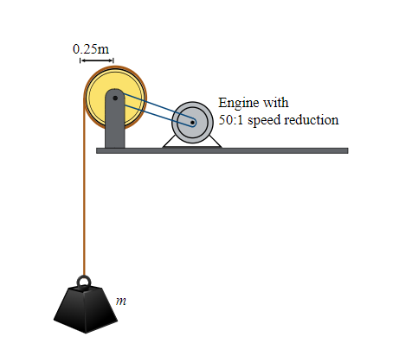

***METHODOLOGY***

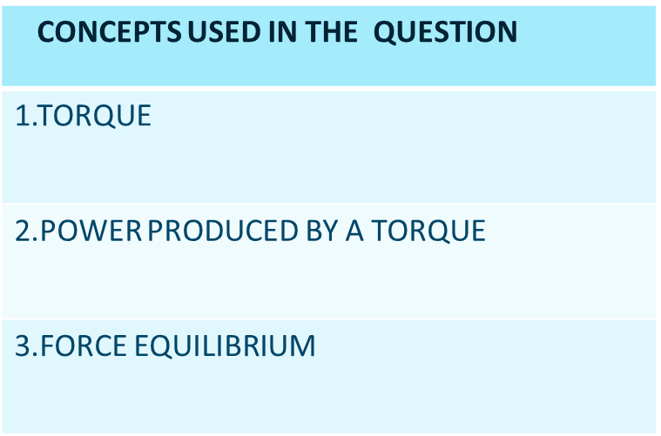

*Step 1 – Finding out the power of the winch in lifting up the object*

*Step 2- Using equilibrium, finding out the weight of the object being lifted up*

*Step 3-With the help of weight finding out the mass of the object being lifted up*

*Step 4 -Using matlab for plotting the variation of maximum weight to parameters like torque provided by the engine , radius of the winch etc*

***CALCULATIONS***

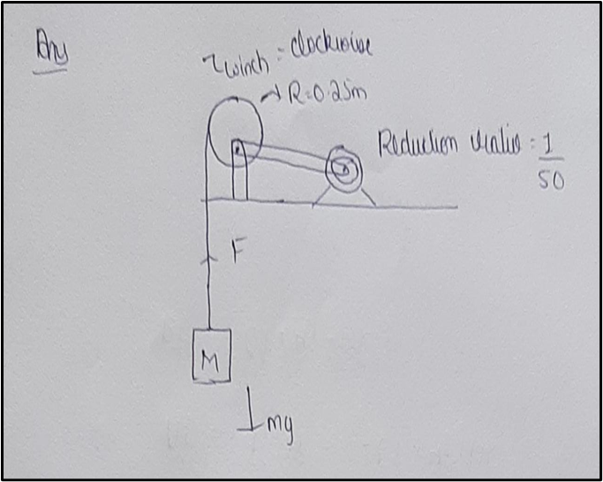

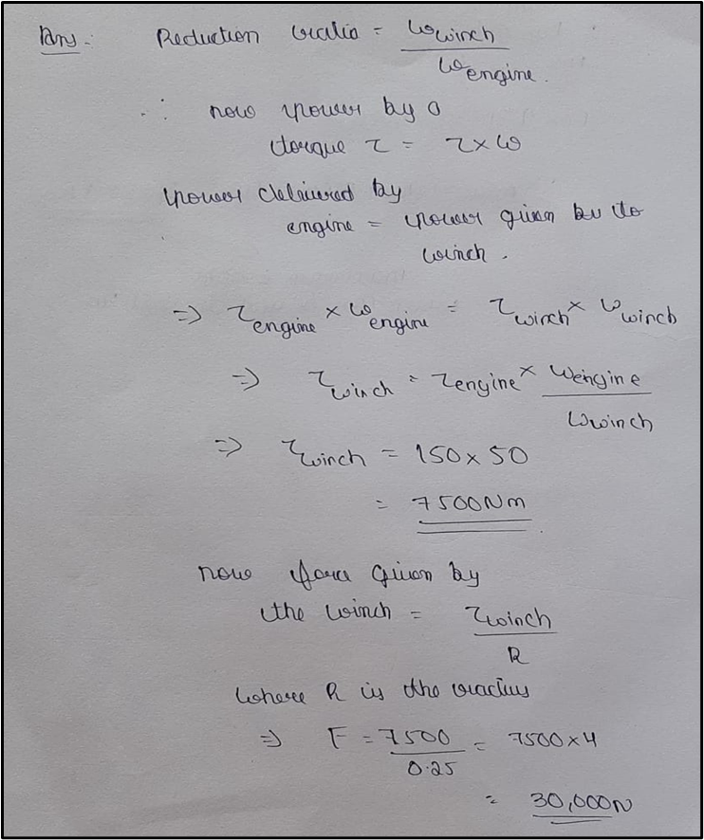

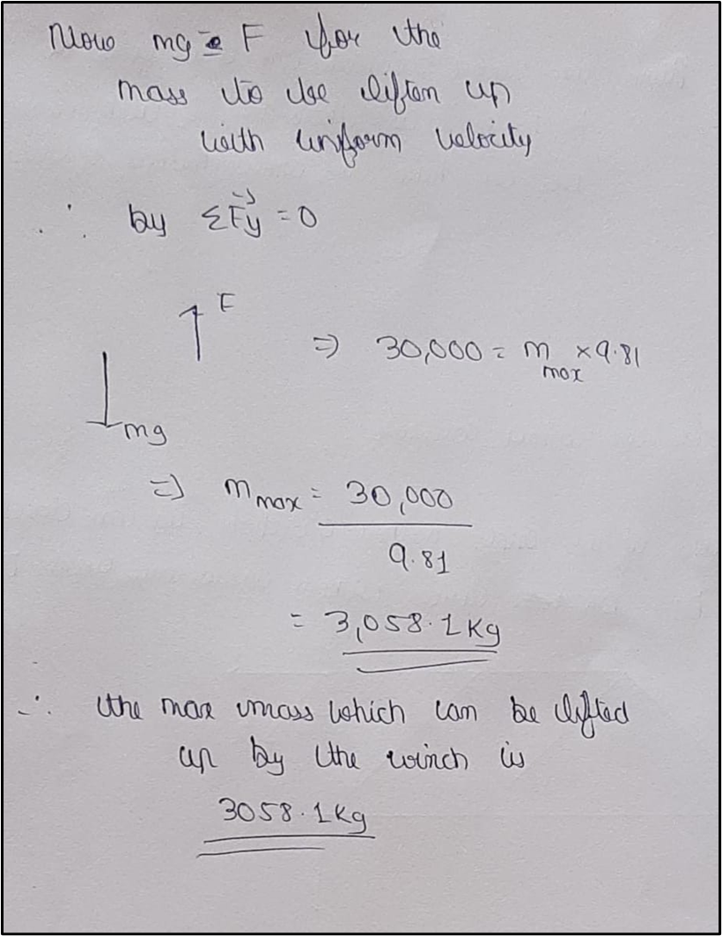

***MATLAB***

%MATLAB PART FOR QUESTION 1

T=input("Enter the torque provided by the engine ");

R= input("Enter the reduction ratio of the engine ");

M=T/(R*0.25*9.81);

disp("The max mass lifted up is ")

disp(M);

M1=1:T;

A=1:T;

for i = 1:T

M1(1,i)=i/(R*0.25*9.81);

end

plot(A,M1)

title("variation of max weight lifted up by the torque to the torque provided by the engine ")

xlabel("Torque in Nm ")

ylabel("mass in kg")

%MATLAB PART FOR QUESTION 2

T=input("Enter the torque provided by the engine ");

R= input("Enter the reduction ratio of the engine ");

r=input("Enter the radius of the winch ");

a=1:r;

M2=1:r;

for i= 1:r

M2(1,i)=T/(R*i*9.81);

end

figure;

plot(a,M2)

title("variation of max weight lifted up by the torque to the radius of the winch ")

xlabel("Torque in Nm ")

ylabel("mass in kg")

***RESULT***

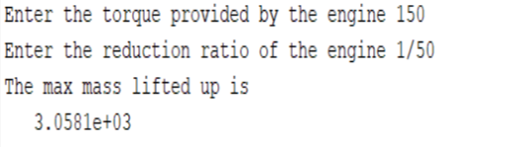

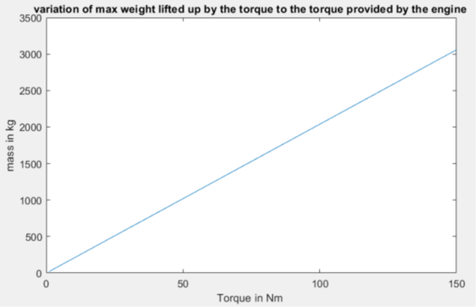

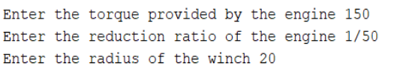

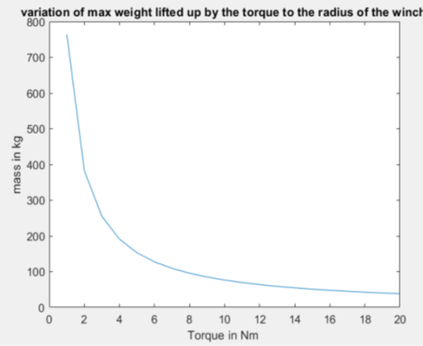

***INTERPRETATION***

With the help of MATLAB-

* We are getting the input values of torque , reduction ratio and radius of the winch from the user
* The user is also displayed the max weight being lifted up
* We are plotting the variation between the mass lifting up and the torque of the engine and the plot is a straight line.We are also drawing the variation of mass and the radius of the winch which is a curve

The above question also helps us in understanding concepts like torque and how it used in real world

**VI.PROBLEM 6**

***PROBLEM DEFENITION***

A Complex structure is given below. The total height of the structure is 2.5 inch. The base length of the structure is 2 inch. Find out the moment of inertia of the given structure with respect to an axis passing through the centroid of the figure. Using matlab-

1. Get tbase as an input from the user and find out the moment of inertia of the figure with respect to the centroid
2. Plot a variation of the moment of inertia of the structure with respect to the x axis with the variation of base from 1 to the given input

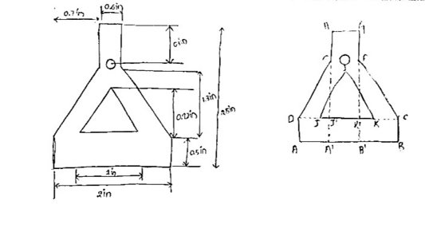

***METHODOLOGY***

|  |
| --- |
| **CONCEPTS USED IN THE QUESTION** |
| 1.MOMENT OF INERTIA OF RIGID BODIES- |
| 2.CENTROID OF RIGID BODIES - |
| 3.PARALLEL AXIS THEOROM - |

*Step 1 – Calculating the centroid of the whole system after finding the centroid of the whole system*

*Step 2 – Calculating the moment of inertia of the whole system with respect to the x axis with the help of moment of inertia of the individual bodies*

*Step 3 – Finding out the moment of inertia of the body wrt centroid with the help of parallel axis theorom*

***CALCULATIONS***

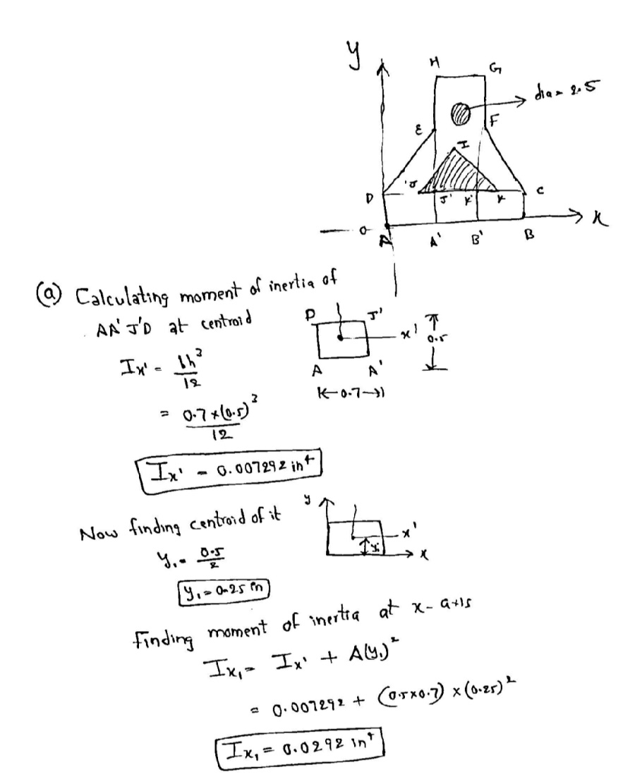

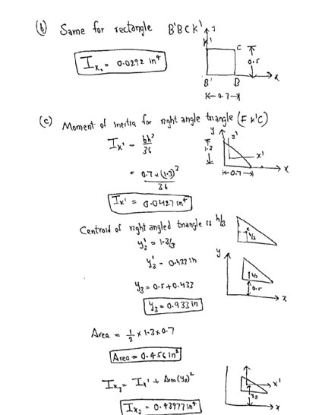

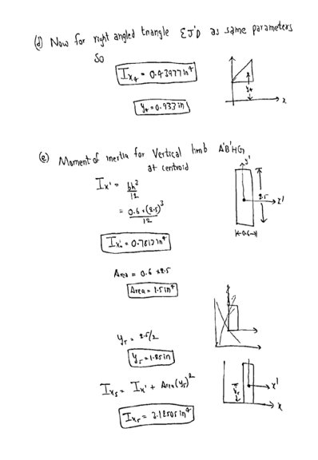

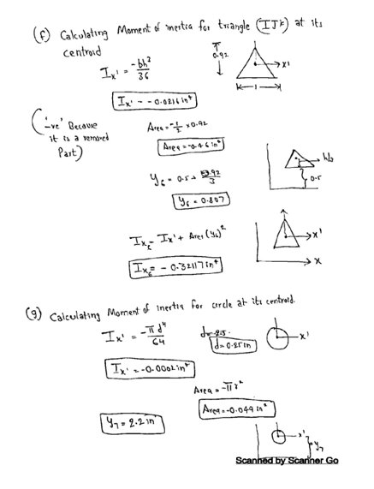

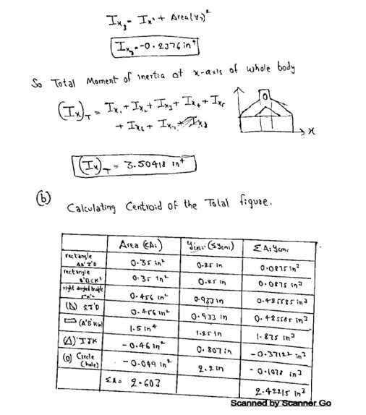

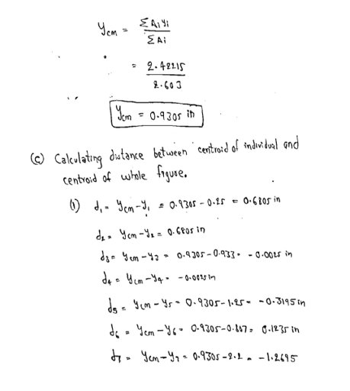

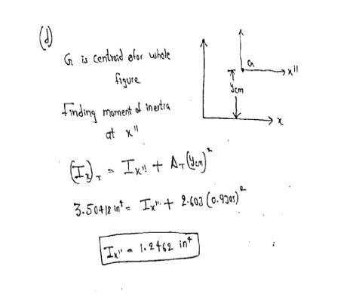

***MATLAB***

b=input("Enter the base length ")

A1=(1.3*(b-0.6))/4; %right angled triangle area

I1=((b-0.6)/2)*(1.3^3)/36; %right angled triangle moment of inertia wrt centroid

dy1=(1.3/3)+0.5;%right angled triangle distance of centroid from x axis

X1=(dy1^2);

S1=(A1*(X1))+I1;%right angled triangle moment of inertia wrt x axis

A2=((b-0.6)*0.5/2); %2 small rectangles area

I2=((b-0.6)/2*(0.5^3))/12; % 2 small rectangles on the base moment of inertia wrt centroid

dy2=0.25;% 2 small rectangles on the base distance of centroid from x axis

X2=(dy2^2);

S2=(A2*(X2))+I2; % 2 small rectangles on the base moment of inertia wrt x axis

A3 = 1.5; % BIG RECTANGLE area

dy3=1.25; % BIG RECTANGLE moment of inertia wrt centroid

I3=(0.6*(2.5^3))/12 % BIG RECTANGLE distance of centroid from x axis

X3=(dy3^2);

S3=(A3*(X3))+I3;% BIG RECTANGLE moment of i

A4 = (3.14*(0.125)^2); %hollow circle area

dy4 = 2.2; %hollow circle moment of inertia wrt centroid

I4 = (3.14*(0.25^4))/64; %hollow circle distance of centroid from x axis

X4=(dy4^2);

S4=(A4*(X4))+I4; %hollow circle moment of inertia wrt x axis

A5=(0.92/2); %hollow TRIANGLE area

dy5=(0.5+(0.92/3)); %hollow TRIANGLE distance of centroid from x axis

I5=((0.92^3)/36); %hollow TRIANGLE moment of inertia wrt centroid

X5=(dy5^2);

S5=(A5*(X5))+I5; %hollow TRIANGLE moment of inertia wrt x axis

S=(2*S1)+(2*S2)+(S3)-S4-S5;%final moment of inertia

disp("The moment of inertia with respect of x axis is ")

disp(S) disp("The moment of inertia with respect of x axis is ")

disp(S)

m1=1:b;

a=1:b;

for i=1:b

%we only need to change the values for right angled triangle and rectangles

%as they are depenedent on b

A1=(1.3*(i-0.6))/4; %right angled triangle area

I1=((i-0.6)/2)*(1.3^3)/36; %right angled triangle

dy1=(1.3/3)+0.5;%right angled triangle moment of inertia wrt centroid

X1=(dy1^2);

S1=(A1*(X1))+I1;%right angled triangle moment of inertia wrt x axis

A2=((i-0.6)*0.5/2); % 2 small rectangles on the base area

I2=((i-0.6)/2*(0.5^3))/12; % 2 small rectangles on the base moment of inertia wrt centroid

dy2=0.25;% 2 small rectangles on the base distance of centroid from x axis

X2=(dy2^2);

S2=(A2*(X2))+I2; % 2 small rectangles on the base moment of inertia wrt x axis

m1(1,i)=(2*S1)+(2*S2)+(S3)-S4-S5;

end

plot(a,m1)

title("Variation of moment of inertia wrt base ")

xlabel("base length ")

ylabel("moment of inertia with respect x axis")

***RESULT***

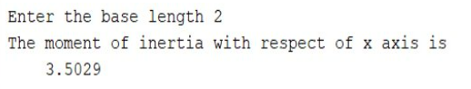

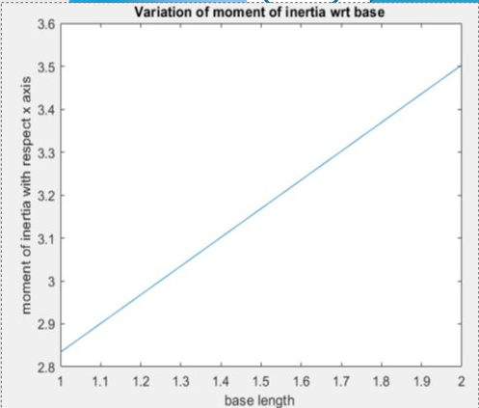

***INTERPRETATION***

With the help of MATLAB-

* We will take input base length from user and calculate total moment of inertia at x-axis.
* Second case we are plotting graph between input base length and moment of inertia which is a straight line.

The problem help us to understand the concept of parallel axis theorem clearly and moment of inertia.

**VII.PROBLEM 7**

***PROBLEM DEFINITION***

Q2. A Crane is used for lifting cars from the ground. At a given height we are told that the tension in each cable is 28 kN Find the resultant of all the tension forces. Also find the cartesian angle of the resultant vector. Using MATLAB

1. Get the weight of the car from the user and find out the tension in each cable assuming that the weight is along the –ve z axis. Also plot the variation of tension forces with the weight from 0 to given weight?
2. Get the tension on each cable from the user and draw the variation of resultant force wrt to tension?
3. Get the E z coordinate from the user and plot the variation of resultant wrt The coordinate?

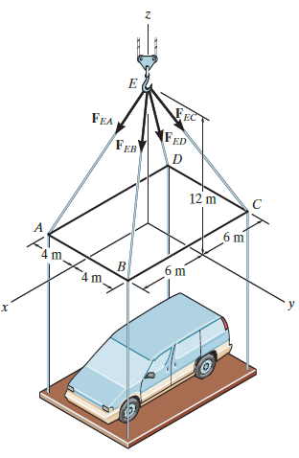

***METHODOLOGY***

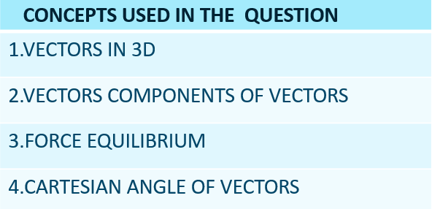

*Step 1- Finding out the unit vectors along all the tension ropes with the help of concept of vectors in 3D*

*Step 2- Getting the tension vectors by multiplying the tension forces with the unit vectors*

*Step 3- Getting the resultant by using vector addition*

*Step 4- Finding the cartesian angles of the resultant vector*

*Step 5 – using MATLAB for finding the required plots*

***CALCULATION***

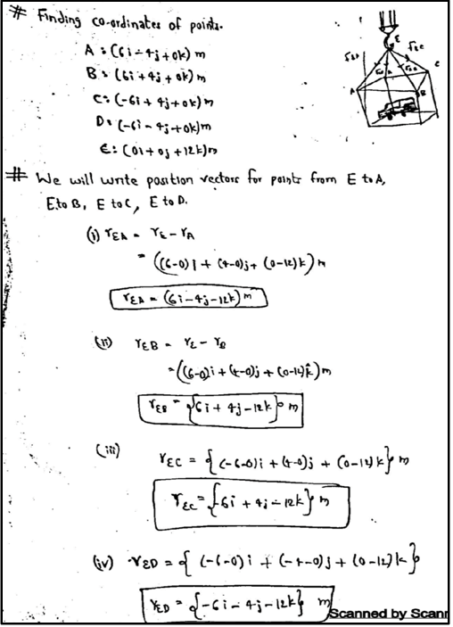

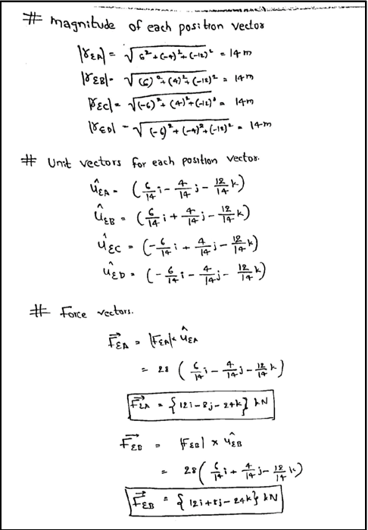

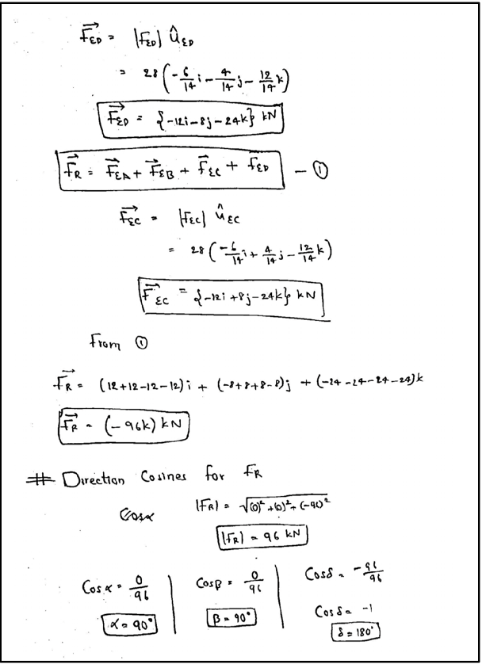

***MATLAB***

%QUESTION 1 MATLAB CODE

D=[-6 -4 0];

C=[-6 4 0];

B=[6 4 0];

A=[6 -4 0];

q=12;

E=[0 0 q];

W= input("Enter the weight of the car ");

AE=E-A;

BE=E-B;

CE=E-C;

DE=E-D;

AECAP=AE/norm(AE);

disp("The cartesian angle wrt x axis for AE is ")

disp(acosd(AECAP(1,1)))

BECAP=BE/norm(BE);

disp("The cartesian angle wrt x axis for BE is ")

disp(acosd(BECAP(1,1)))

CECAP=CE/norm(CE);

disp("The cartesian angle wrt x axis for CE is ")

disp(acosd(CECAP(1,1)))

DECAP=DE/norm(DE);

disp("The cartesian angle wrt x axis for DE is ")

disp(acosd(DECAP(1,1)))

R=AECAP+BECAP+CECAP+DECAP;

T=W/norm(R);

disp("The tension in each cable is ")

disp(T)

x=1:W;

T1=1:W;

for i=1:W

T1(1,i)=W/i;

end

figure;

plot(x,T1)

title("VARIATION OF TENSION IN EACH CABLE VS WEIGHT OF THE CAR IN kN ")

xlabel("Weight in kN")

ylabel("Tension in kN")

%QUESTION 2 MATLAB

T=input("Enter the tension for each cable ");

disp("THE RESULTANT TENSION IS ");

W=norm(R)*T;

disp(W)

r=1:T;

r2=1:T;

for o = 1:T

r2(1,o)=norm(R)*o;

end

figure;

plot(r,r2)

title("THE VARIATION OF RESULTANT TENSION WITH TENSION IN EACH CABLE")

ylabel("Weight in kN")

xlabel("resultant in kN")

%QUESTION 3 MATLAB

q=input("Enter the z coordinate of E ");

T=input("Enter the tension in each cable ");

a=1:q;

a1=1:q;

for i=1:q

D=[-6 -4 0];

C=[-6 4 0];

B=[6 4 0];

A=[6 -4 0];

E=[0 0 i];

AE=E-A;

BE=E-B;

CE=E-C;

DE=E-D;

AECAP=AE/norm(AE);

BECAP=BE/norm(BE);

CECAP=CE/norm(CE);

DECAP=DE/norm(DE);

R=AECAP+BECAP+CECAP+DECAP;

a1(1,i)= norm(R)*T;

end

figure;

plot(a,a1)

title("THE VARIATION OF RESULTANT TENSION WITH E COORDINATE")

xlabel("coordinate")

ylabel("resultant tension in kN")

***RESULT***

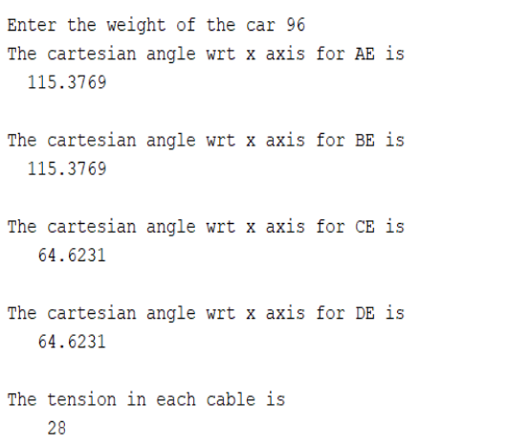

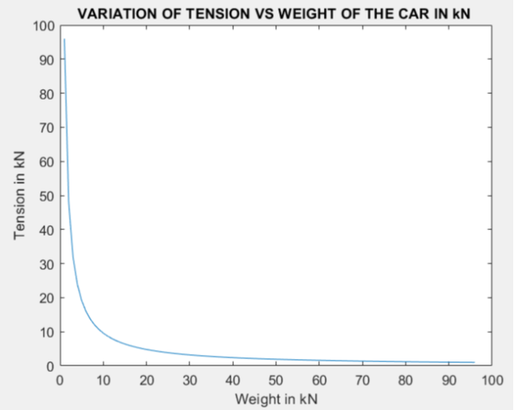

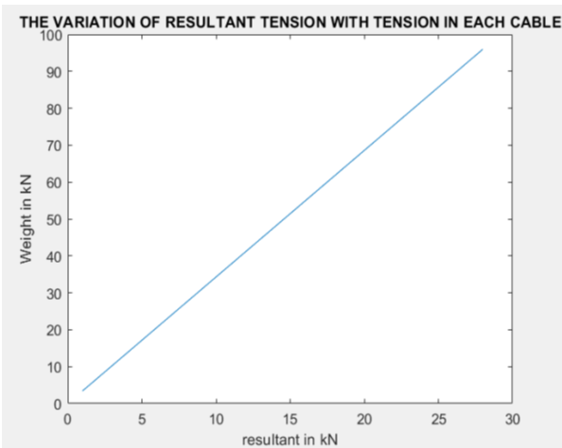

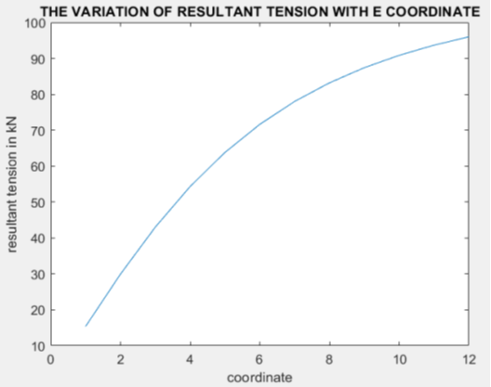

***INTERPRETATION***

With the help of MATLAB-

1.we are able to pot the variation of tension in each cable with resultant tension i.e., weight of the car

2.Also the variation of resultant tension with the tension in each cables.

3.Also the variation of resultant tension with the z coordinate of the E point

The above question can be used to understand the concepts of vectors. It also gives us a brief idea about how vectors are useful for defining our real life 3d world